# Homework 2

## Task 1

Create the database ZIW35:

[CREATE](http://localhost/phpmyadmin/url.php?url=http://dev.mysql.com/doc/refman/5.5/en/create-database.html) [DATABASE](http://localhost/phpmyadmin/url.php?url=http://dev.mysql.com/doc/refman/5.5/en/create-database.html) ZIW35

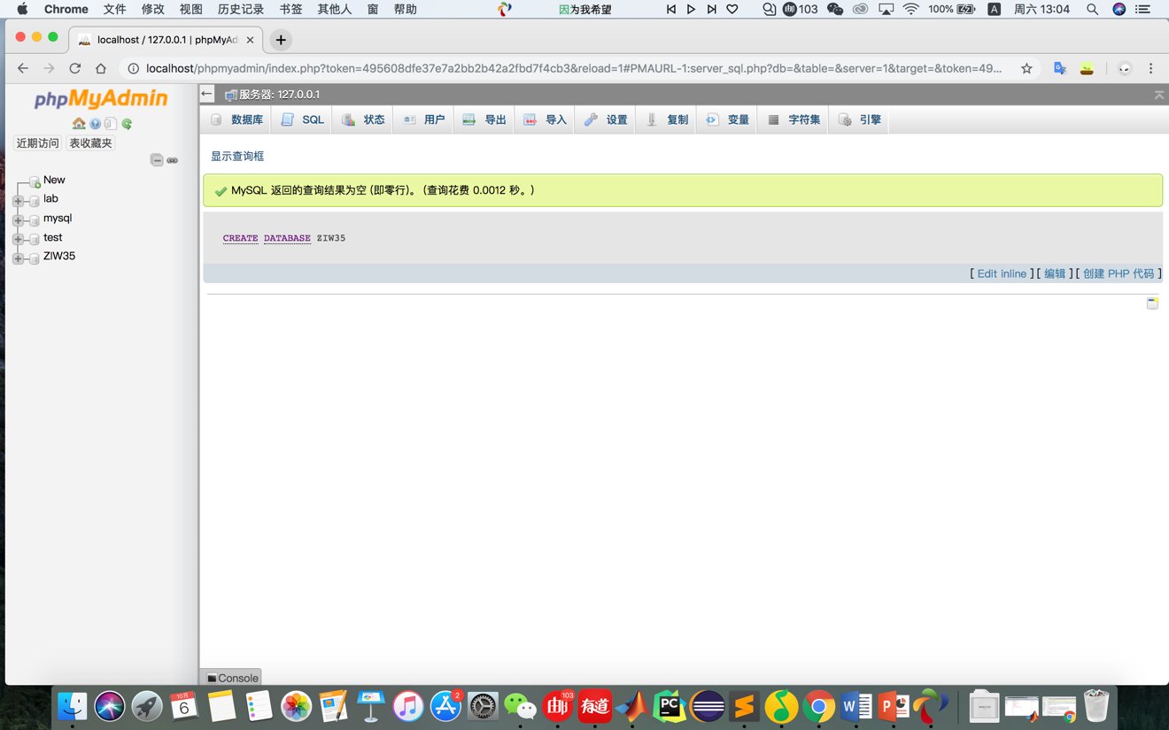

### Create the table movies, actors, locations:

CREATE TABLE Movies(movie\_id int NOT NULL, title varchar(200) NOT NULL, release\_date datetime NOT NULL, plot\_description varchar(4000) NOT NULL, PRIMARY KEY(movie\_id))

[CREATE](http://localhost/phpmyadmin/url.php?url=http://dev.mysql.com/doc/refman/5.5/en/create-table.html) [TABLE](http://localhost/phpmyadmin/url.php?url=http://dev.mysql.com/doc/refman/5.5/en/create-table.html) actors (actor\_id [INT](http://localhost/phpmyadmin/url.php?url=http://dev.mysql.com/doc/refman/5.5/en/numeric-types.html) [NOT](http://localhost/phpmyadmin/url.php?url=http://dev.mysql.com/doc/refman/5.5/en/logical-operators.html#operator_not) null, first\_name [varchar](http://localhost/phpmyadmin/url.php?url=http://dev.mysql.com/doc/refman/5.5/en/string-types.html)(100) [NOT](http://localhost/phpmyadmin/url.php?url=http://dev.mysql.com/doc/refman/5.5/en/logical-operators.html#operator_not) null, last\_name [varchar](http://localhost/phpmyadmin/url.php?url=http://dev.mysql.com/doc/refman/5.5/en/string-types.html)(100) [not](http://localhost/phpmyadmin/url.php?url=http://dev.mysql.com/doc/refman/5.5/en/logical-operators.html#operator_not) null, birth\_date [datetime](http://localhost/phpmyadmin/url.php?url=http://dev.mysql.com/doc/refman/5.5/en/date-and-time-types.html) [NOT](http://localhost/phpmyadmin/url.php?url=http://dev.mysql.com/doc/refman/5.5/en/logical-operators.html#operator_not) null, biography[varchar](http://localhost/phpmyadmin/url.php?url=http://dev.mysql.com/doc/refman/5.5/en/string-types.html)(1000) [not](http://localhost/phpmyadmin/url.php?url=http://dev.mysql.com/doc/refman/5.5/en/logical-operators.html#operator_not) null )

[create](http://localhost/phpmyadmin/url.php?url=http://dev.mysql.com/doc/refman/5.5/en/create-table.html) [TABLE](http://localhost/phpmyadmin/url.php?url=http://dev.mysql.com/doc/refman/5.5/en/create-table.html) locations(location\_id [int](http://localhost/phpmyadmin/url.php?url=http://dev.mysql.com/doc/refman/5.5/en/numeric-types.html) [not](http://localhost/phpmyadmin/url.php?url=http://dev.mysql.com/doc/refman/5.5/en/logical-operators.html#operator_not) null, location\_name [varchar](http://localhost/phpmyadmin/url.php?url=http://dev.mysql.com/doc/refman/5.5/en/string-types.html)(100) [not](http://localhost/phpmyadmin/url.php?url=http://dev.mysql.com/doc/refman/5.5/en/logical-operators.html#operator_not) null, street\_address [varchar](http://localhost/phpmyadmin/url.php?url=http://dev.mysql.com/doc/refman/5.5/en/string-types.html)(150) [not](http://localhost/phpmyadmin/url.php?url=http://dev.mysql.com/doc/refman/5.5/en/logical-operators.html#operator_not) null, city [varchar](http://localhost/phpmyadmin/url.php?url=http://dev.mysql.com/doc/refman/5.5/en/string-types.html)(100) [not](http://localhost/phpmyadmin/url.php?url=http://dev.mysql.com/doc/refman/5.5/en/logical-operators.html#operator_not) null, state[char](http://localhost/phpmyadmin/url.php?url=http://dev.mysql.com/doc/refman/5.5/en/string-types.html)(2) [not](http://localhost/phpmyadmin/url.php?url=http://dev.mysql.com/doc/refman/5.5/en/logical-operators.html#operator_not) null, zip [varchar](http://localhost/phpmyadmin/url.php?url=http://dev.mysql.com/doc/refman/5.5/en/string-types.html)(5) [not](http://localhost/phpmyadmin/url.php?url=http://dev.mysql.com/doc/refman/5.5/en/logical-operators.html#operator_not) null )

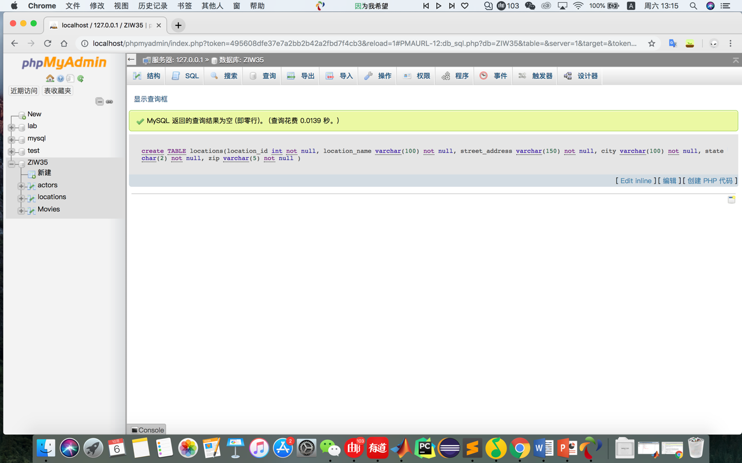

## Task 2

Create two junction tables:

[CREATE](http://localhost/phpmyadmin/url.php?url=http://dev.mysql.com/doc/refman/5.5/en/create-table.html) [TABLE](http://localhost/phpmyadmin/url.php?url=http://dev.mysql.com/doc/refman/5.5/en/create-table.html) movies\_actors(movie\_id [int](http://localhost/phpmyadmin/url.php?url=http://dev.mysql.com/doc/refman/5.5/en/numeric-types.html) [NOT](http://localhost/phpmyadmin/url.php?url=http://dev.mysql.com/doc/refman/5.5/en/logical-operators.html#operator_not) NULL, actor\_id [int](http://localhost/phpmyadmin/url.php?url=http://dev.mysql.com/doc/refman/5.5/en/numeric-types.html) [NOT](http://localhost/phpmyadmin/url.php?url=http://dev.mysql.com/doc/refman/5.5/en/logical-operators.html#operator_not) NULL)

[CREATE](http://localhost/phpmyadmin/url.php?url=http://dev.mysql.com/doc/refman/5.5/en/create-table.html) [TABLE](http://localhost/phpmyadmin/url.php?url=http://dev.mysql.com/doc/refman/5.5/en/create-table.html) movies\_locations(movie\_id [int](http://localhost/phpmyadmin/url.php?url=http://dev.mysql.com/doc/refman/5.5/en/numeric-types.html) [NOT](http://localhost/phpmyadmin/url.php?url=http://dev.mysql.com/doc/refman/5.5/en/logical-operators.html#operator_not) NULL, location\_id [int](http://localhost/phpmyadmin/url.php?url=http://dev.mysql.com/doc/refman/5.5/en/numeric-types.html) [NOT](http://localhost/phpmyadmin/url.php?url=http://dev.mysql.com/doc/refman/5.5/en/logical-operators.html#operator_not) NULL)

create the appropriate foreign key:

[ALTER](http://localhost/phpmyadmin/url.php?url=http://dev.mysql.com/doc/refman/5.5/en/alter-table.html" \t "mysql_doc) [TABLE](http://localhost/phpmyadmin/url.php?url=http://dev.mysql.com/doc/refman/5.5/en/alter-table.html) movies\_actors ADD CONSTRAINT FOREIGN KEY (movie\_id) REFERENCES Movies(movie\_id) ON [DELETE](http://localhost/phpmyadmin/url.php?url=http://dev.mysql.com/doc/refman/5.5/en/delete.html) CASCADE ON [UPDATE](http://localhost/phpmyadmin/url.php?url=http://dev.mysql.com/doc/refman/5.5/en/update.html) CASCADE

ALTER TABLE movies\_actors ADD CONSTRAINT FOREIGN KEY (actor\_id) REFERENCES actors(actor\_id) ON DELETE CASCADE ON UPDATE CASCADE

ALTER TABLE movies\_locations ADD CONSTRAINT FOREIGN KEY (movie\_id) REFERENCES Movies(movie\_id) ON DELETE CASCADE ON UPDATE CASCADE

ALTER TABLE movies\_locations ADD CONSTRAINT FOREIGN KEY (location\_id) REFERENCES locations(location\_id) ON DELETE CASCADE ON UPDATE CASCADE

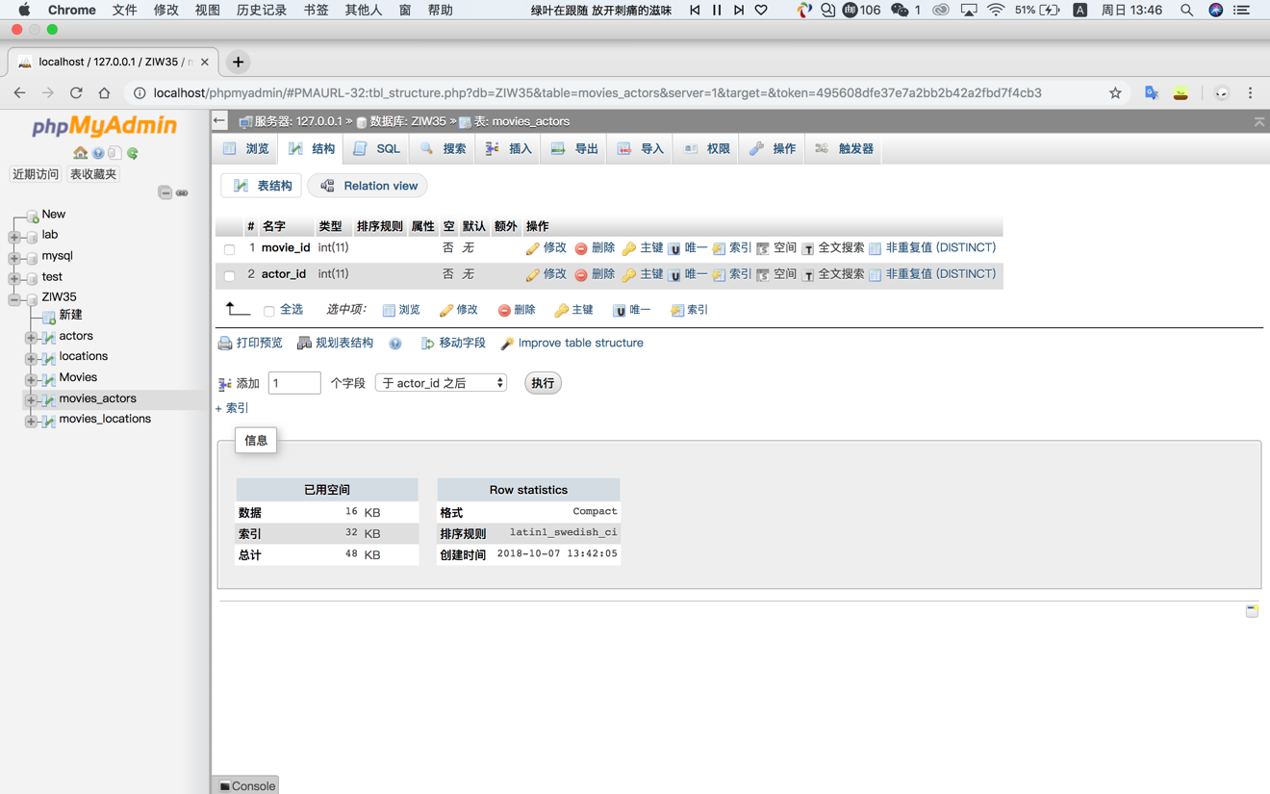

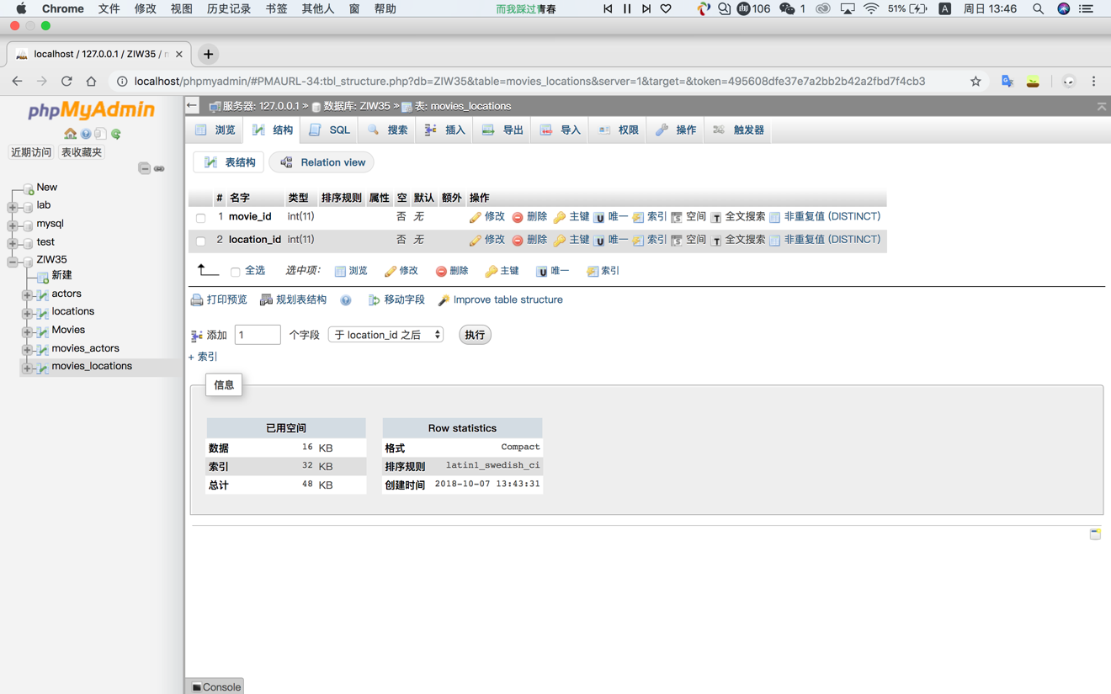

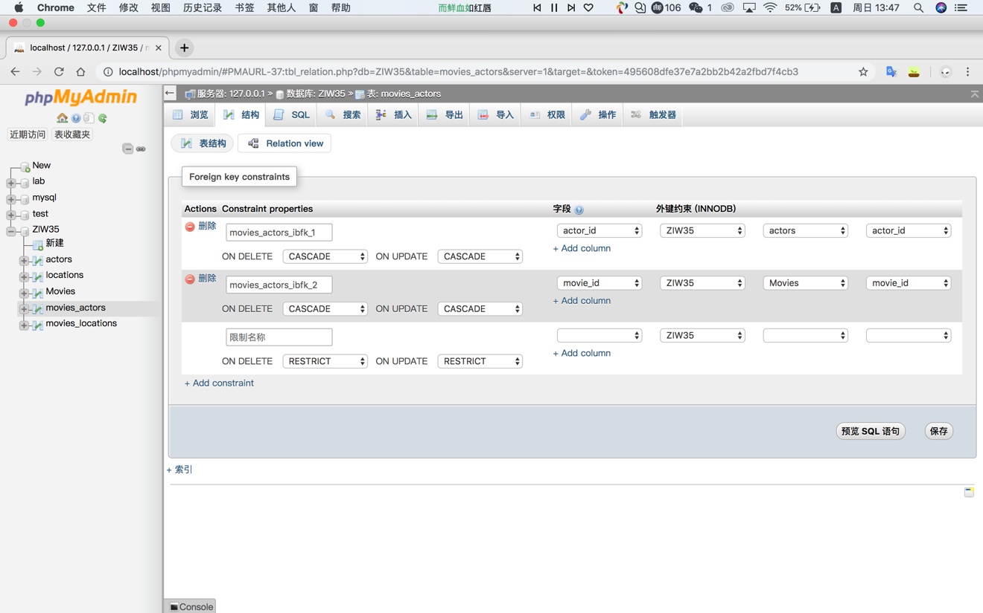

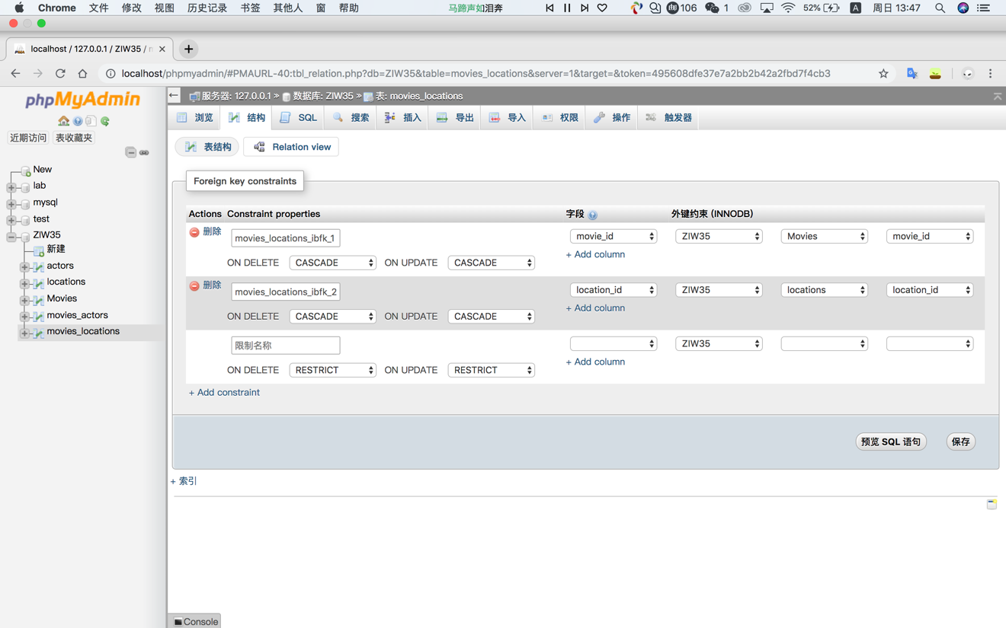

## Task 3

Insert 5 movies in the movies table:

[INSERT](http://localhost/phpmyadmin/url.php?url=http://dev.mysql.com/doc/refman/5.5/en/insert.html" \t "mysql_doc) INTO `Movies`(`movie\_id`, `title`, `release\_date`, `plot\_description`) [VALUES](http://localhost/phpmyadmin/url.php?url=http://dev.mysql.com/doc/refman/5.5/en/miscellaneous-functions.html#function_values) ('111111','Deadpool 2','2018-05-18','Deadpool 2 is a 2018 American superhero film based on the Marvel Comics character Deadpool, distributed by 20th Century Fox.')

[INSERT](http://localhost/phpmyadmin/url.php?url=http://dev.mysql.com/doc/refman/5.5/en/insert.html" \t "mysql_doc) INTO `Movies`(`movie\_id`, `title`, `release\_date`, `plot\_description`) [VALUES](http://localhost/phpmyadmin/url.php?url=http://dev.mysql.com/doc/refman/5.5/en/miscellaneous-functions.html#function_values) ('111112','Deadpool',' 2016-02-12','Deadpool is a 2016 American superhero film based on the Marvel Comics character of the same name, distributed by 20th Century Fox.')

[INSERT](http://localhost/phpmyadmin/url.php?url=http://dev.mysql.com/doc/refman/5.5/en/insert.html" \t "mysql_doc) INTO `Movies`(`movie\_id`, `title`, `release\_date`, `plot\_description`) [VALUES](http://localhost/phpmyadmin/url.php?url=http://dev.mysql.com/doc/refman/5.5/en/miscellaneous-functions.html#function_values) ('111113','Murder on the Orient Express ','2017-11-10','Murder on the Orient Express is a 2017 mystery drama film directed by Kenneth Branagh with a screenplay by Michael Green, based on the 1934 novel of the same name by Agatha Christie.')

[INSERT](http://localhost/phpmyadmin/url.php?url=http://dev.mysql.com/doc/refman/5.5/en/insert.html" \t "mysql_doc) INTO `Movies`(`movie\_id`, `title`, `release\_date`, `plot\_description`) [VALUES](http://localhost/phpmyadmin/url.php?url=http://dev.mysql.com/doc/refman/5.5/en/miscellaneous-functions.html#function_values) ('111114','Inferno','2016-10-28','nferno is a 2016 American mystery thriller film directed by Ron Howard and written by David Koepp, based on the 2013 novel of the same name by Dan Brown.')

[INSERT](http://localhost/phpmyadmin/url.php?url=http://dev.mysql.com/doc/refman/5.5/en/insert.html" \t "mysql_doc) INTO `Movies`(`movie\_id`, `title`, `release\_date`, `plot\_description`) [VALUES](http://localhost/phpmyadmin/url.php?url=http://dev.mysql.com/doc/refman/5.5/en/miscellaneous-functions.html#function_values) ('111115','Iron Man 3','2013-05-03','Iron Man 3 (stylized onscreen as Iron Man Three) is a 2013 American superhero film based on the Marvel Comics character Iron Man, produced by Marvel Studios and distributed by Walt Disney Studios Motion Pictures.')

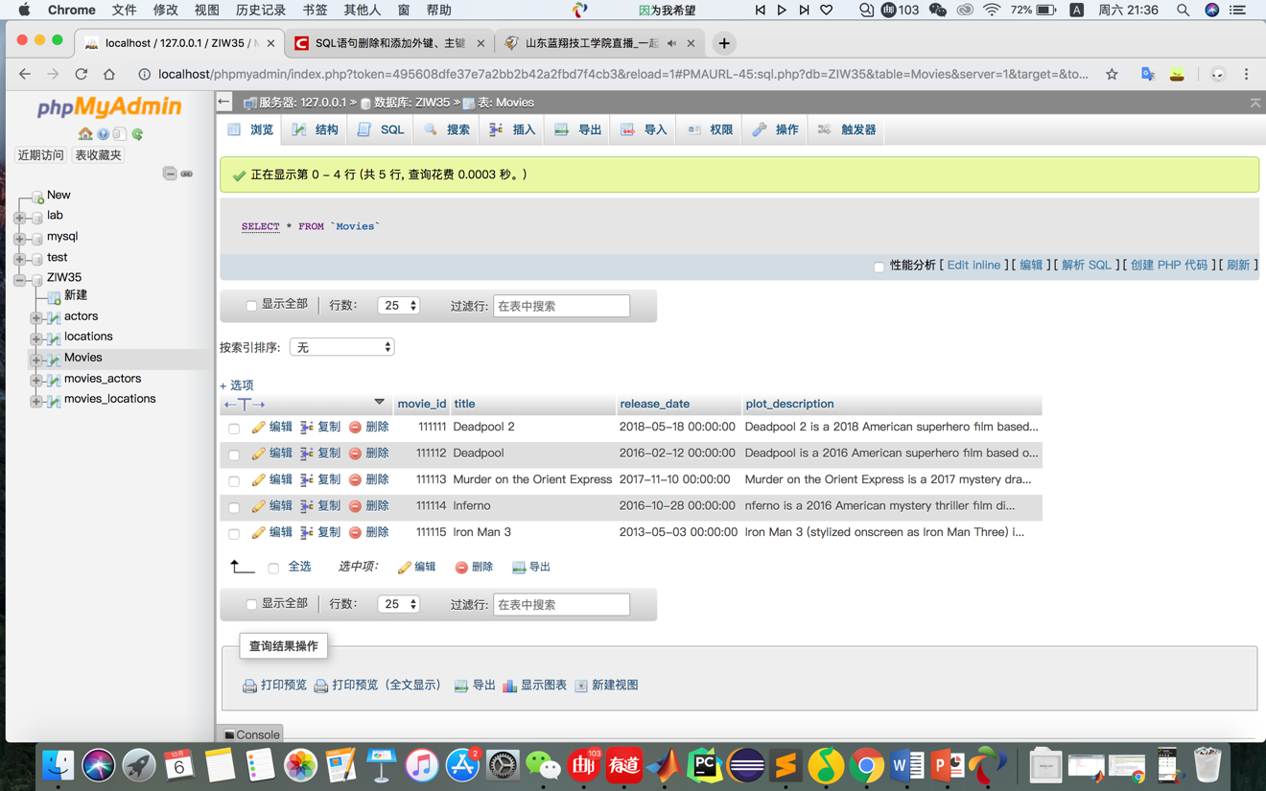

Insert into actors:

[INSERT](http://localhost/phpmyadmin/url.php?url=http://dev.mysql.com/doc/refman/5.5/en/insert.html" \t "mysql_doc) INTO `actors`(`actor\_id`, `first\_name`, `last\_name`, `birth\_date`, `biography`) [VALUES](http://localhost/phpmyadmin/url.php?url=http://dev.mysql.com/doc/refman/5.5/en/miscellaneous-functions.html#function_values) ('211111','Downey','Robert','1965-04-04','Robert John Downey Jr. (born April 4, 1965)[2] is an American actor and singer.')

[INSERT](http://localhost/phpmyadmin/url.php?url=http://dev.mysql.com/doc/refman/5.5/en/insert.html" \t "mysql_doc) INTO `actors`(`actor\_id`, `first\_name`, `last\_name`, `birth\_date`, `biography`) [VALUES](http://localhost/phpmyadmin/url.php?url=http://dev.mysql.com/doc/refman/5.5/en/miscellaneous-functions.html#function_values) ('211112','Johansson','Scarlett','1984-11-22','Scarlett Ingrid Johansson (/dʒoʊˈhænsən/; born November 22, 1984) is an American actress and singer.')

[INSERT](http://localhost/phpmyadmin/url.php?url=http://dev.mysql.com/doc/refman/5.5/en/insert.html" \t "mysql_doc) INTO `actors`(`actor\_id`, `first\_name`, `last\_name`, `birth\_date`, `biography`) [VALUES](http://localhost/phpmyadmin/url.php?url=http://dev.mysql.com/doc/refman/5.5/en/miscellaneous-functions.html#function_values) ('211113','Evans','Chris','1981-06-13','Christopher Robert Evans[1] (born June 13, 1981) is an American actor. ')

[INSERT](http://localhost/phpmyadmin/url.php?url=http://dev.mysql.com/doc/refman/5.5/en/insert.html" \t "mysql_doc) INTO `actors`(`actor\_id`, `first\_name`, `last\_name`, `birth\_date`, `biography`) [VALUES](http://localhost/phpmyadmin/url.php?url=http://dev.mysql.com/doc/refman/5.5/en/miscellaneous-functions.html#function_values) ('211114','Hemsworth','Chris','1983-08-11','Christopher Hemsworth (born 11 August 1983) is an Australian actor.')

[INSERT](http://localhost/phpmyadmin/url.php?url=http://dev.mysql.com/doc/refman/5.5/en/insert.html" \t "mysql_doc) INTO `actors`(`actor\_id`, `first\_name`, `last\_name`, `birth\_date`, `biography`) [VALUES](http://localhost/phpmyadmin/url.php?url=http://dev.mysql.com/doc/refman/5.5/en/miscellaneous-functions.html#function_values) ('211115','Ruffalo','Mark','1967-11-22','Mark Alan Ruffalo (/ˈrʌfəloʊ/; born November 22, 1967) is an American actor, filmmaker and activist who made his screen debut in an episode of CBS Summer Playhouse (1989), followed by minor film roles.')

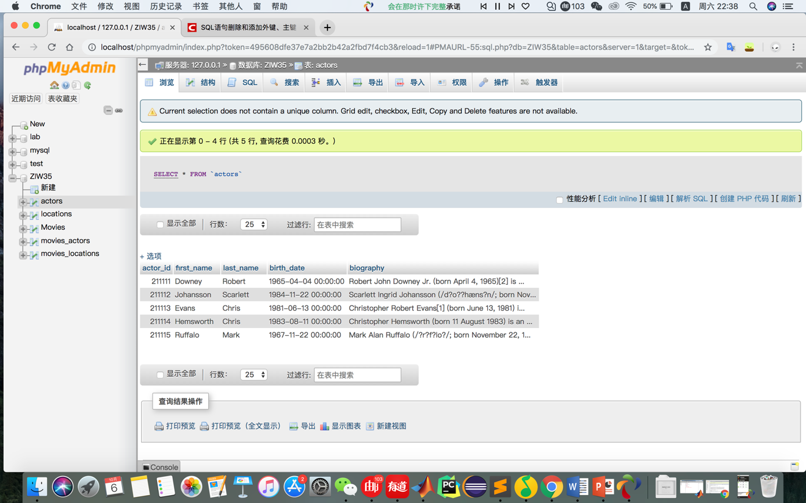

Insert into locations:

[INSERT](http://localhost/phpmyadmin/url.php?url=http://dev.mysql.com/doc/refman/5.5/en/insert.html" \t "mysql_doc) INTO `locations`(`location\_id`, `location\_name`, `street\_address`, `city`, `state`, `zip`) [VALUES](http://localhost/phpmyadmin/url.php?url=http://dev.mysql.com/doc/refman/5.5/en/miscellaneous-functions.html#function_values) ('311111','AMC Waterfront 22','300 W Waterfront Dr, West Homestead','Pittsburgh','PA','15120')

[INSERT](http://localhost/phpmyadmin/url.php?url=http://dev.mysql.com/doc/refman/5.5/en/insert.html" \t "mysql_doc) INTO `locations`(`location\_id`, `location\_name`, `street\_address`, `city`, `state`, `zip`) [VALUES](http://localhost/phpmyadmin/url.php?url=http://dev.mysql.com/doc/refman/5.5/en/miscellaneous-functions.html#function_values) ('311112','Row House Cinema','4115 Butler St, Pittsburgh','pittsburgh','PA','15201')

[INSERT](http://localhost/phpmyadmin/url.php?url=http://dev.mysql.com/doc/refman/5.5/en/insert.html" \t "mysql_doc) INTO `locations`(`location\_id`, `location\_name`, `street\_address`, `city`, `state`, `zip`) [VALUES](http://localhost/phpmyadmin/url.php?url=http://dev.mysql.com/doc/refman/5.5/en/miscellaneous-functions.html#function_values) ('311113','The Rangos Giant Cinema','1 Allegheny Ave, Pittsburgh','pittsburgh','PA','15212')

INSERT INTO `locations`(`location\_id`, `location\_name`, `street\_address`, `city`, `state`, `zip`) VALUES ('311114','MovieScoop Waterworks Cinemas','930 Freeport Rd, Pittsburgh','Pittsburgh','PA','15238')

[INSERT](http://localhost/phpmyadmin/url.php?url=http://dev.mysql.com/doc/refman/5.5/en/insert.html" \t "mysql_doc) INTO `locations`(`location\_id`, `location\_name`, `street\_address`, `city`, `state`, `zip`) [VALUES](http://localhost/phpmyadmin/url.php?url=http://dev.mysql.com/doc/refman/5.5/en/miscellaneous-functions.html#function_values) ('311115','Regent Square Theater','1035 S Braddock Ave, Pittsburgh','Pittsburgh','PA','15218')

## Task 4

[INSERT](http://localhost/phpmyadmin/url.php?url=http://dev.mysql.com/doc/refman/5.5/en/insert.html" \t "mysql_doc) INTO `movies\_actors`(`movie\_id`, `actor\_id`) [VALUES](http://localhost/phpmyadmin/url.php?url=http://dev.mysql.com/doc/refman/5.5/en/miscellaneous-functions.html#function_values) (111111,211111)

[INSERT](http://localhost/phpmyadmin/url.php?url=http://dev.mysql.com/doc/refman/5.5/en/insert.html) INTO `movies\_actors`(`movie\_id`, `actor\_id`) [VALUES](http://localhost/phpmyadmin/url.php?url=http://dev.mysql.com/doc/refman/5.5/en/miscellaneous-functions.html#function_values) (111112,211112)

[INSERT](http://localhost/phpmyadmin/url.php?url=http://dev.mysql.com/doc/refman/5.5/en/insert.html) INTO `movies\_actors`(`movie\_id`, `actor\_id`) [VALUES](http://localhost/phpmyadmin/url.php?url=http://dev.mysql.com/doc/refman/5.5/en/miscellaneous-functions.html#function_values) (111113,211113)

[INSERT](http://localhost/phpmyadmin/url.php?url=http://dev.mysql.com/doc/refman/5.5/en/insert.html) INTO `movies\_actors`(`movie\_id`, `actor\_id`) [VALUES](http://localhost/phpmyadmin/url.php?url=http://dev.mysql.com/doc/refman/5.5/en/miscellaneous-functions.html#function_values) (111114,211114)

[INSERT](http://localhost/phpmyadmin/url.php?url=http://dev.mysql.com/doc/refman/5.5/en/insert.html) INTO `movies\_actors`(`movie\_id`, `actor\_id`) [VALUES](http://localhost/phpmyadmin/url.php?url=http://dev.mysql.com/doc/refman/5.5/en/miscellaneous-functions.html#function_values) (111115,211115)

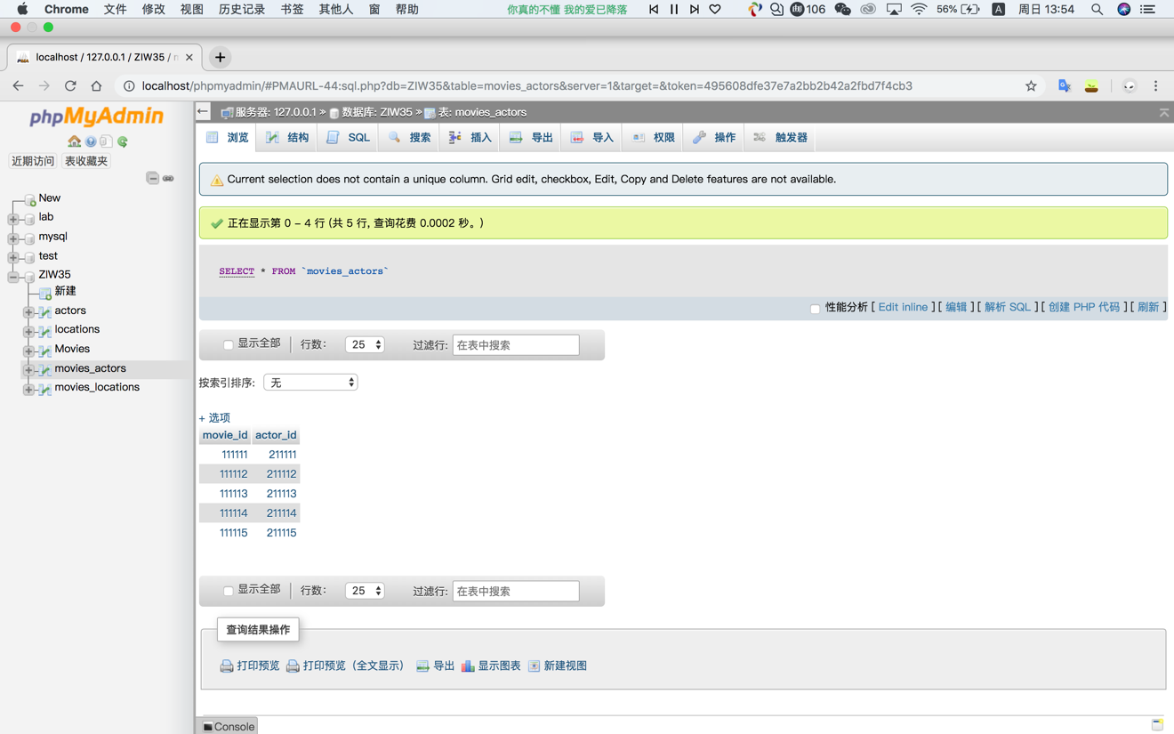

[INSERT](http://localhost/phpmyadmin/url.php?url=http://dev.mysql.com/doc/refman/5.5/en/insert.html" \t "mysql_doc) INTO `movies\_locations`(`movie\_id`, `location\_id`) [VALUES](http://localhost/phpmyadmin/url.php?url=http://dev.mysql.com/doc/refman/5.5/en/miscellaneous-functions.html#function_values) (111111,311111)

[INSERT](http://localhost/phpmyadmin/url.php?url=http://dev.mysql.com/doc/refman/5.5/en/insert.html) INTO `movies\_locations`(`movie\_id`, `location\_id`) [VALUES](http://localhost/phpmyadmin/url.php?url=http://dev.mysql.com/doc/refman/5.5/en/miscellaneous-functions.html#function_values) (111112,311112)

INSERT INTO `movies\_locations`(`movie\_id`, `location\_id`) VALUES (111113,311113)

[INSERT](http://localhost/phpmyadmin/url.php?url=http://dev.mysql.com/doc/refman/5.5/en/insert.html) INTO `movies\_locations`(`movie\_id`, `location\_id`) [VALUES](http://localhost/phpmyadmin/url.php?url=http://dev.mysql.com/doc/refman/5.5/en/miscellaneous-functions.html#function_values) (111114,311114)

INSERT INTO `movies\_locations`(`movie\_id`, `location\_id`) VALUES (111115,311115)

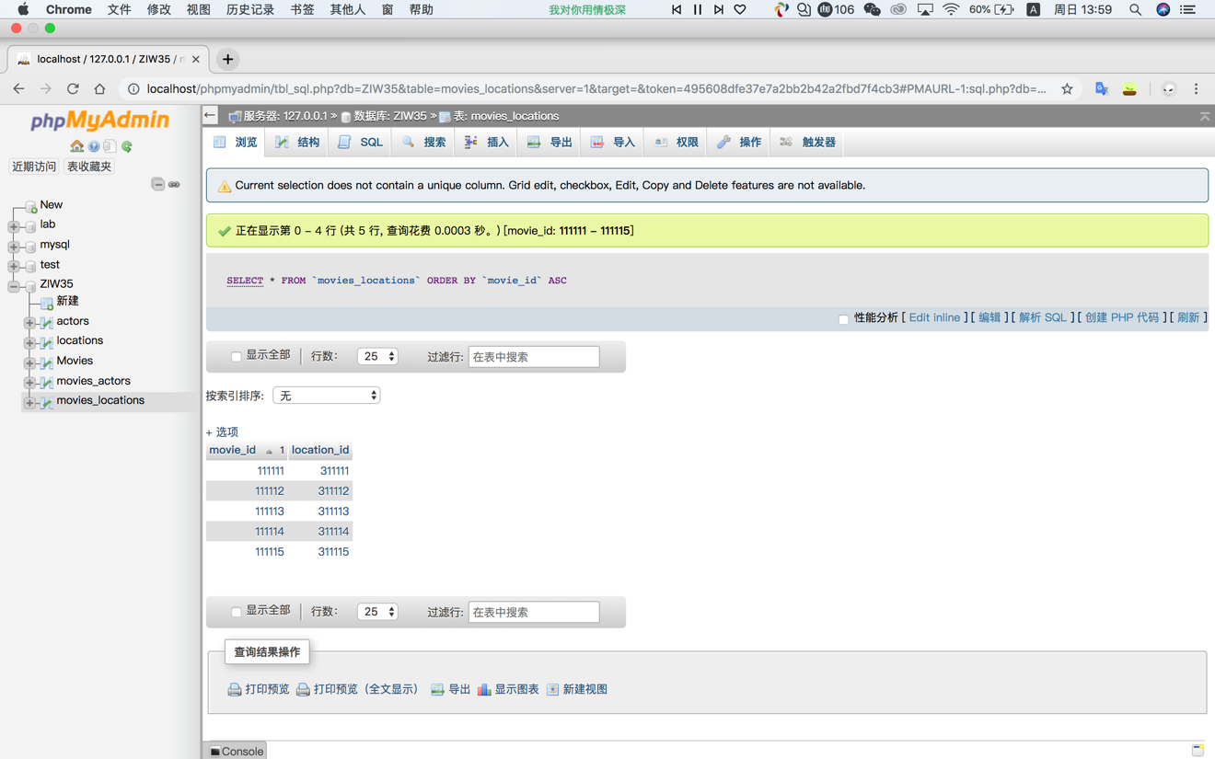

## Task 5

[SELECT](http://localhost/phpmyadmin/url.php?url=http://dev.mysql.com/doc/refman/5.5/en/select.html) \* FROM `actors` WHERE last\_name [LIKE](http://localhost/phpmyadmin/url.php?url=http://dev.mysql.com/doc/refman/5.5/en/string-comparison-functions.html#operator_like) '%t'

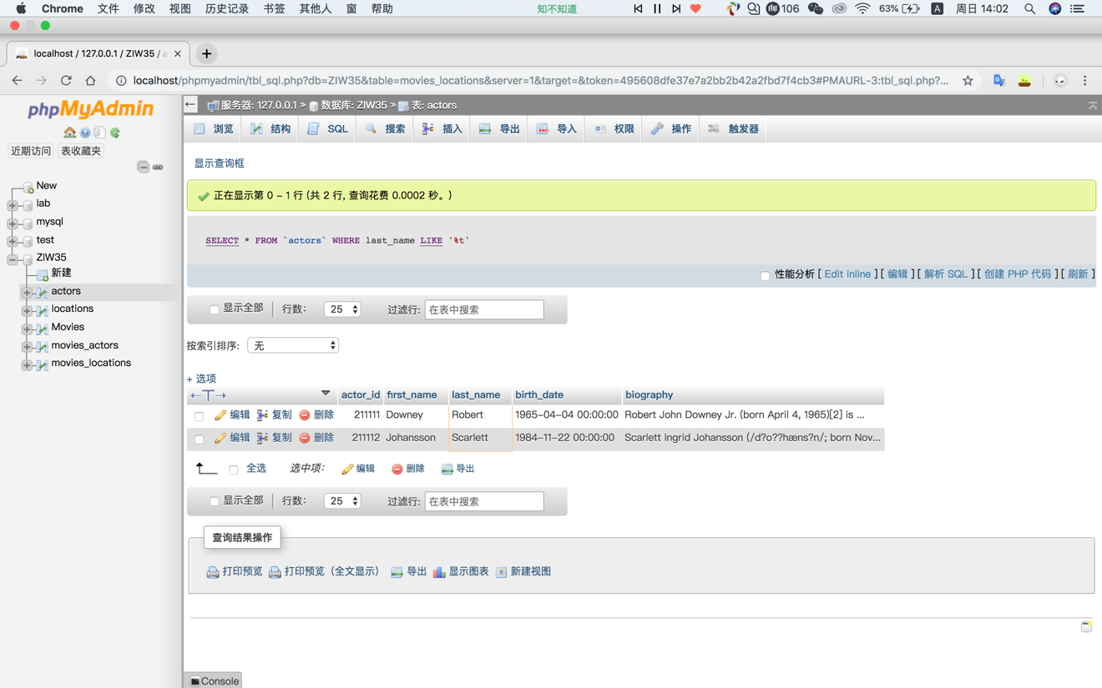

## Task 6

[SELECT](http://localhost/phpmyadmin/url.php?url=http://dev.mysql.com/doc/refman/5.5/en/select.html) location\_name, street\_address, city FROM locations ORDER BY location\_name desc

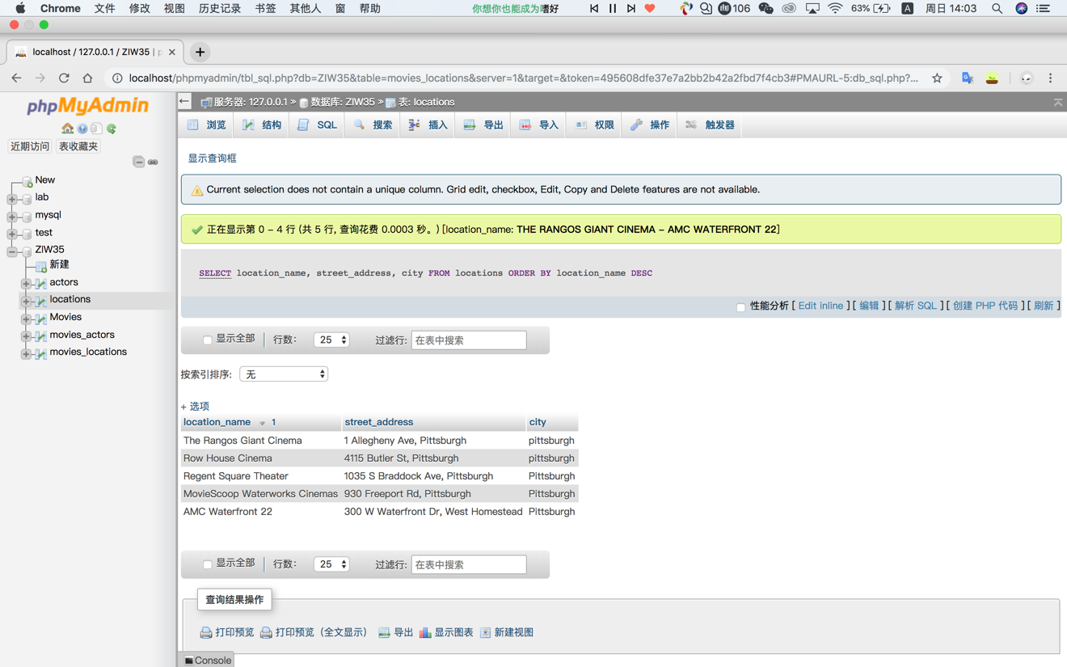

## Task 7

[SELECT](http://localhost/phpmyadmin/url.php?url=http://dev.mysql.com/doc/refman/5.5/en/select.html) \* FROM Movies WHERE release\_date BETWEEN '2015-01-01' [AND](http://localhost/phpmyadmin/url.php?url=http://dev.mysql.com/doc/refman/5.5/en/logical-operators.html#operator_and) '2017-01-01'

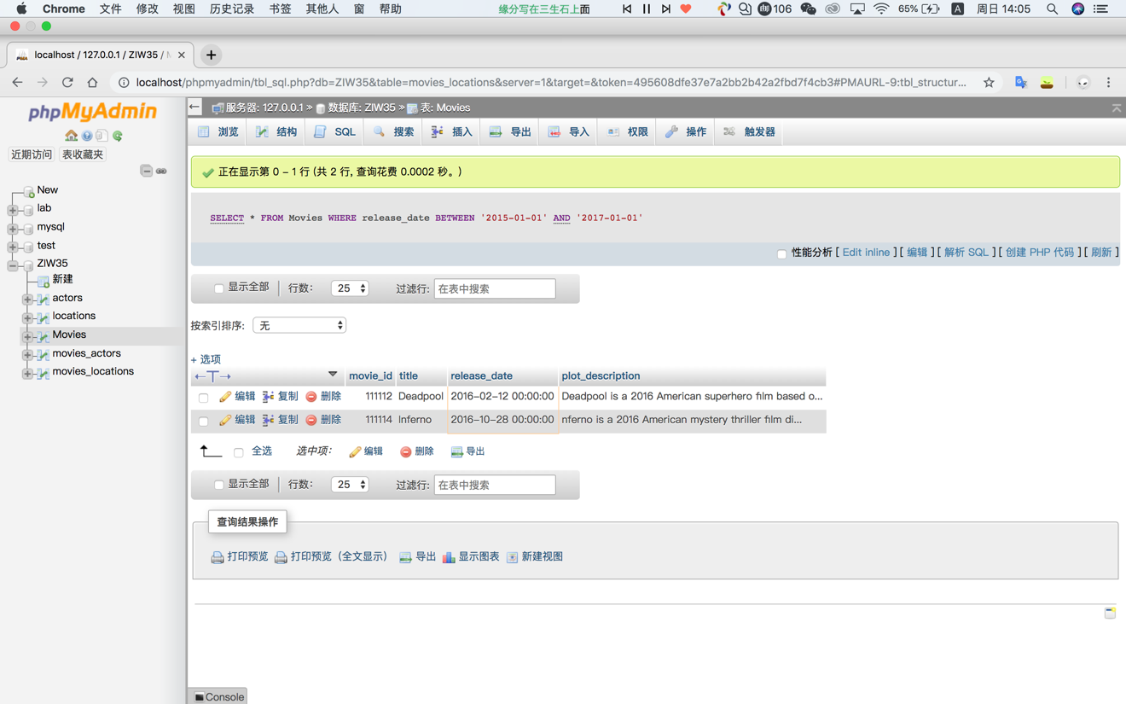

## Task 8

[UPDATE](http://localhost/phpmyadmin/url.php?url=http://dev.mysql.com/doc/refman/5.5/en/update.html) locations [SET](http://localhost/phpmyadmin/url.php?url=http://dev.mysql.com/doc/refman/5.5/en/set.html) zip = '15217'

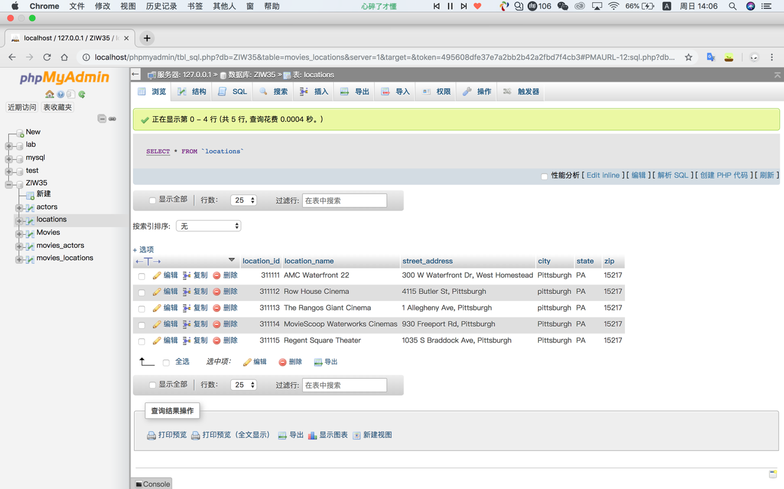

## Task 9

[DELETE](http://localhost/phpmyadmin/url.php?url=http://dev.mysql.com/doc/refman/5.5/en/delete.html) FROM actors WHERE last\_name = 'Mark'

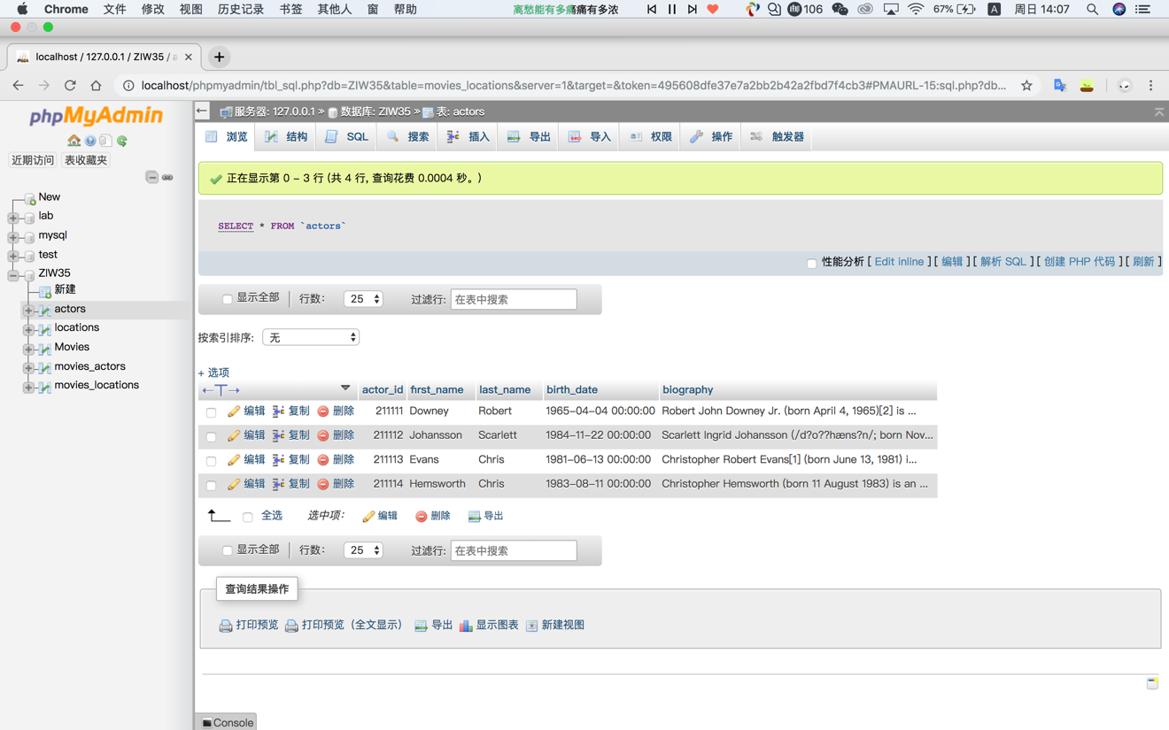

## Task 10

ALTER TABLE actors ADD actor\_horoscope varchar(200) NOT NULL

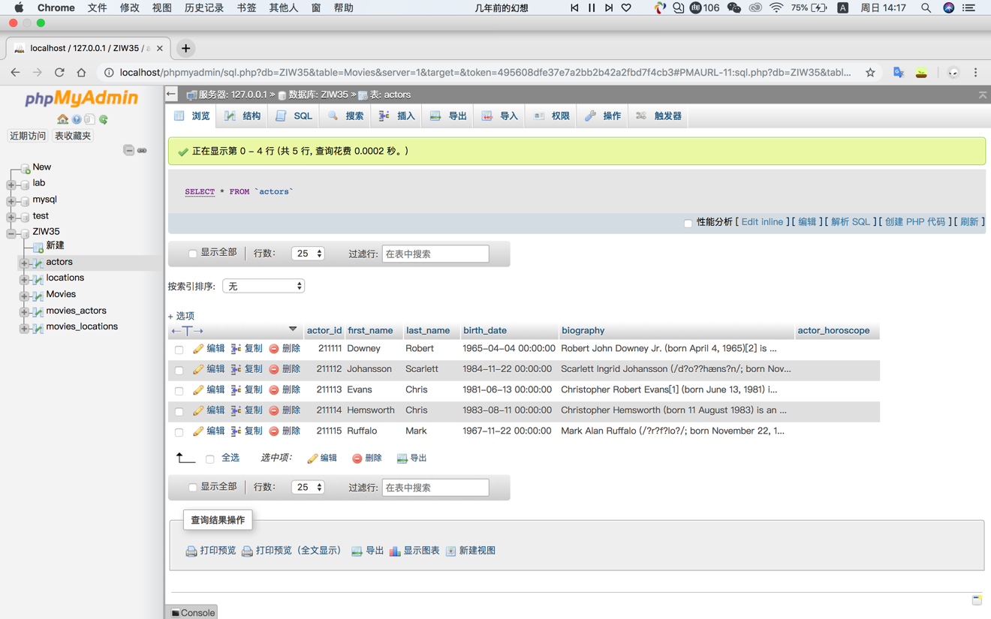

[UPDATE](http://localhost/phpmyadmin/url.php?url=http://dev.mysql.com/doc/refman/5.5/en/update.html" \t "mysql_doc) actors [SET](http://localhost/phpmyadmin/url.php?url=http://dev.mysql.com/doc/refman/5.5/en/set.html) actor\_horoscope = 'Gemini' WHERE actor\_id = 211111

[UPDATE](http://localhost/phpmyadmin/url.php?url=http://dev.mysql.com/doc/refman/5.5/en/update.html" \t "mysql_doc) actors [SET](http://localhost/phpmyadmin/url.php?url=http://dev.mysql.com/doc/refman/5.5/en/set.html) actor\_horoscope = 'Lion' WHERE actor\_id = 211112

[UPDATE](http://localhost/phpmyadmin/url.php?url=http://dev.mysql.com/doc/refman/5.5/en/update.html" \t "mysql_doc) actors [SET](http://localhost/phpmyadmin/url.php?url=http://dev.mysql.com/doc/refman/5.5/en/set.html) actor\_horoscope = 'Cancer' WHERE actor\_id = 211113

[UPDATE](http://localhost/phpmyadmin/url.php?url=http://dev.mysql.com/doc/refman/5.5/en/update.html" \t "mysql_doc) actors [SET](http://localhost/phpmyadmin/url.php?url=http://dev.mysql.com/doc/refman/5.5/en/set.html) actor\_horoscope = 'Taurus ' WHERE actor\_id = 211114

[UPDATE](http://localhost/phpmyadmin/url.php?url=http://dev.mysql.com/doc/refman/5.5/en/update.html" \t "mysql_doc) actors [SET](http://localhost/phpmyadmin/url.php?url=http://dev.mysql.com/doc/refman/5.5/en/set.html) actor\_horoscope = 'Aries ' WHERE actor\_id = 211115

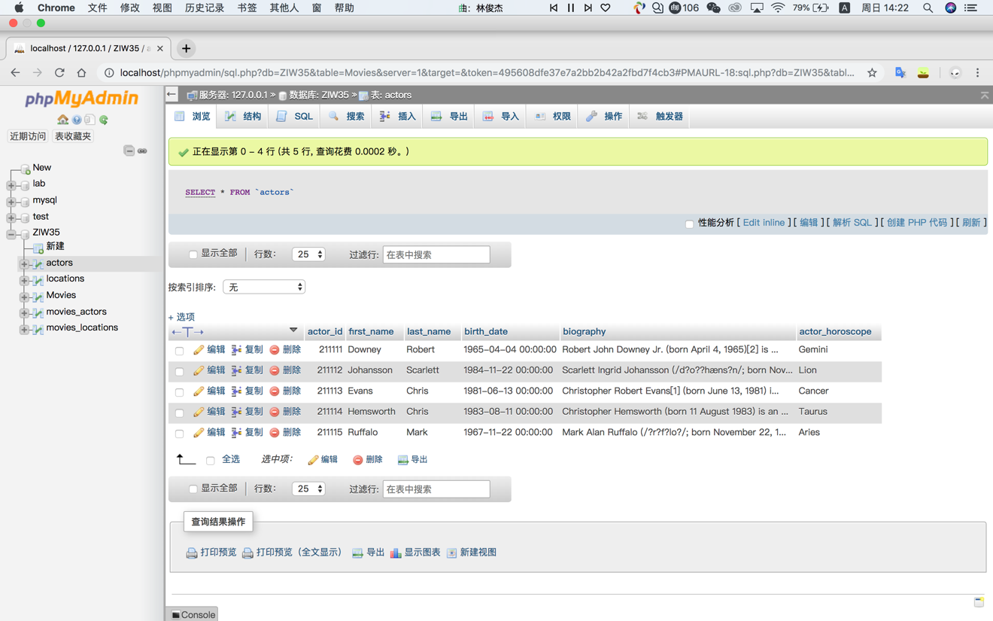

[SELECT](http://localhost/phpmyadmin/url.php?url=http://dev.mysql.com/doc/refman/5.5/en/select.html) \* FROM Movies WHERE EXISTS([SELECT](http://localhost/phpmyadmin/url.php?url=http://dev.mysql.com/doc/refman/5.5/en/select.html) 1 FROM movies\_actors INNER JOIN actors ON movies\_actors.actor\_id = actors.actor\_id WHERE movies\_actors.movie\_id =Movies.movie\_id [AND](http://localhost/phpmyadmin/url.php?url=http://dev.mysql.com/doc/refman/5.5/en/logical-operators.html#operator_and) actors.actor\_horoscope = 'Gemini')

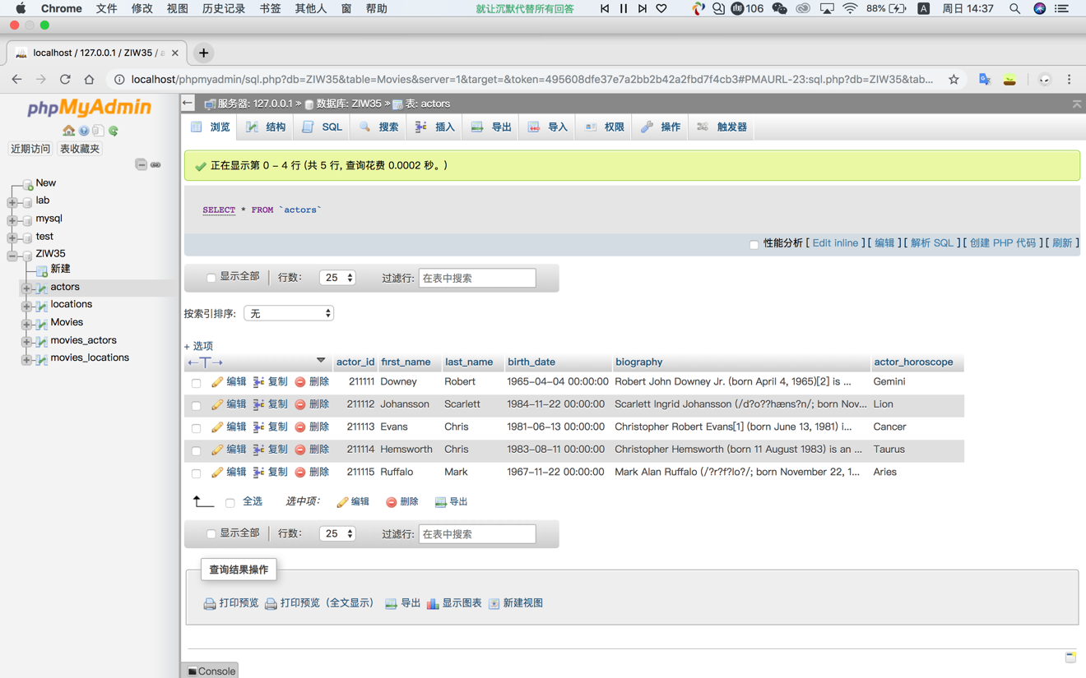

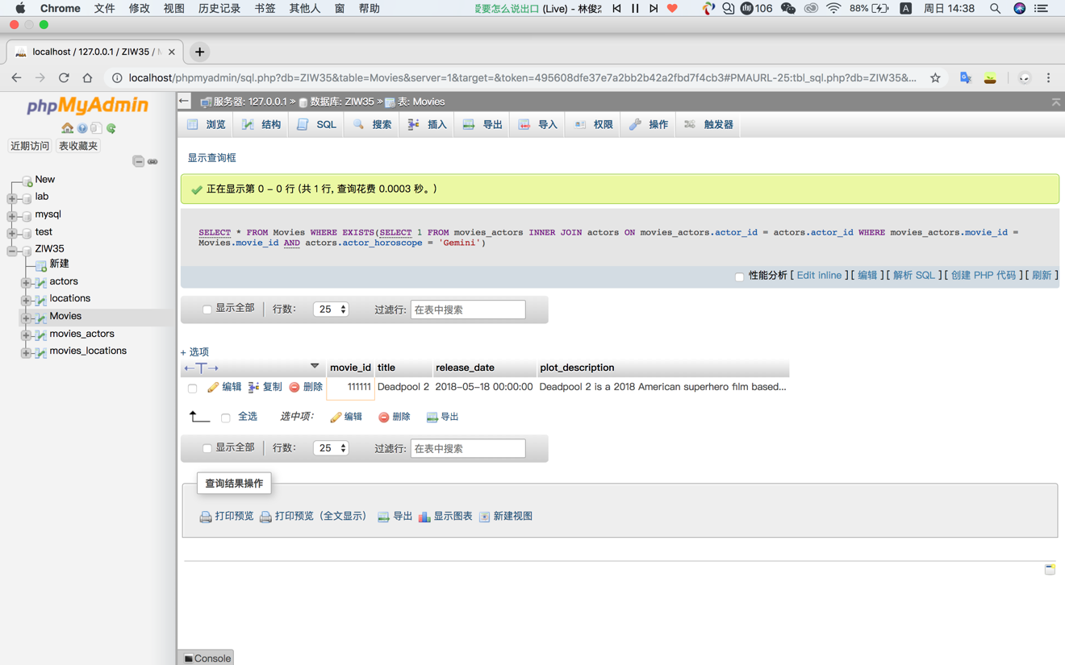

## Task 11

INSERT INTO `actors`(`actor\_id`, `first\_name`, `last\_name`, `birth\_date`, `biography`) VALUES ('211116','peter','smith','1968-05-01','qwert')

[INSERT](http://localhost/phpmyadmin/url.php?url=http://dev.mysql.com/doc/refman/5.5/en/insert.html) INTO `actors`(`actor\_id`, `first\_name`, `last\_name`, `birth\_date`, `biography`) [VALUES](http://localhost/phpmyadmin/url.php?url=http://dev.mysql.com/doc/refman/5.5/en/miscellaneous-functions.html#function_values) ('211117','ham','smith','1970-06-01','qwery')

[INSERT](http://localhost/phpmyadmin/url.php?url=http://dev.mysql.com/doc/refman/5.5/en/insert.html) INTO `actors`(`actor\_id`, `first\_name`, `last\_name`, `birth\_date`, `biography`) [VALUES](http://localhost/phpmyadmin/url.php?url=http://dev.mysql.com/doc/refman/5.5/en/miscellaneous-functions.html#function_values) ('211118','like','smith','1972-09-01','qwero')

[INSERT](http://localhost/phpmyadmin/url.php?url=http://dev.mysql.com/doc/refman/5.5/en/insert.html) INTO `actors`(`actor\_id`, `first\_name`, `last\_name`, `birth\_date`, `biography`) [VALUES](http://localhost/phpmyadmin/url.php?url=http://dev.mysql.com/doc/refman/5.5/en/miscellaneous-functions.html#function_values) ('211119','pop','smith','1976-10-01','qwerp')

[INSERT](http://localhost/phpmyadmin/url.php?url=http://dev.mysql.com/doc/refman/5.5/en/insert.html) INTO `actors`(`actor\_id`, `first\_name`, `last\_name`, `birth\_date`, `biography`) [VALUES](http://localhost/phpmyadmin/url.php?url=http://dev.mysql.com/doc/refman/5.5/en/miscellaneous-functions.html#function_values) ('211110','ipss','smith','1978-12-01','qweru')

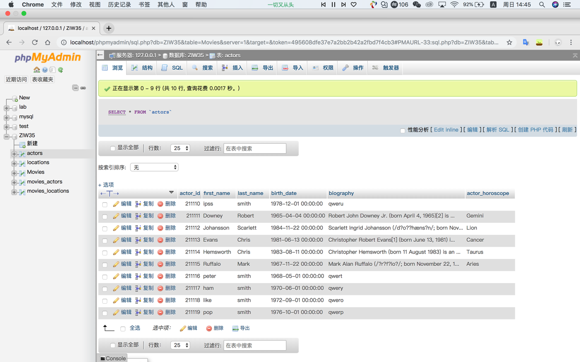

[INSERT](http://localhost/phpmyadmin/url.php?url=http://dev.mysql.com/doc/refman/5.5/en/insert.html" \t "mysql_doc) INTO `movies\_actors`(`movie\_id`, `actor\_id`) [VALUES](http://localhost/phpmyadmin/url.php?url=http://dev.mysql.com/doc/refman/5.5/en/miscellaneous-functions.html#function_values) (111111,211110)

[INSERT](http://localhost/phpmyadmin/url.php?url=http://dev.mysql.com/doc/refman/5.5/en/insert.html" \t "mysql_doc) INTO `movies\_actors`(`movie\_id`, `actor\_id`) [VALUES](http://localhost/phpmyadmin/url.php?url=http://dev.mysql.com/doc/refman/5.5/en/miscellaneous-functions.html#function_values) (111112,211116)

[INSERT](http://localhost/phpmyadmin/url.php?url=http://dev.mysql.com/doc/refman/5.5/en/insert.html) INTO `movies\_actors`(`movie\_id`, `actor\_id`) [VALUES](http://localhost/phpmyadmin/url.php?url=http://dev.mysql.com/doc/refman/5.5/en/miscellaneous-functions.html#function_values) (111113,211117)

[INSERT](http://localhost/phpmyadmin/url.php?url=http://dev.mysql.com/doc/refman/5.5/en/insert.html) INTO `movies\_actors`(`movie\_id`, `actor\_id`) [VALUES](http://localhost/phpmyadmin/url.php?url=http://dev.mysql.com/doc/refman/5.5/en/miscellaneous-functions.html#function_values) (111114,211118)

[INSERT](http://localhost/phpmyadmin/url.php?url=http://dev.mysql.com/doc/refman/5.5/en/insert.html) INTO `movies\_actors`(`movie\_id`, `actor\_id`) [VALUES](http://localhost/phpmyadmin/url.php?url=http://dev.mysql.com/doc/refman/5.5/en/miscellaneous-functions.html#function_values) (111115,211119)



SELECT\* FROM Movies as m, movies\_actors as ma, actors as a WHERE a.actor\_id = ma.actor\_id AND ma.movie\_id= m.movie\_id GROUP BY m.movie\_id ORDER BY AVG(TIMESTAMPDIFF(YEAR, `birth\_date`, CURDATE())) DESC LIMIT 1

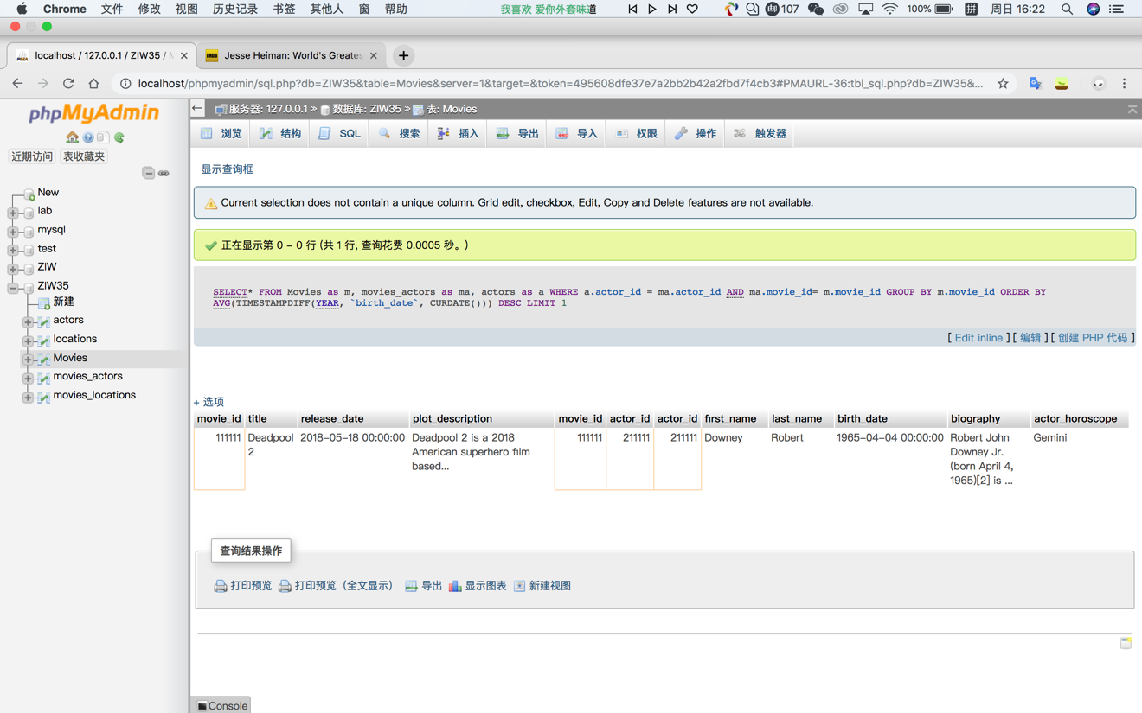

## Task 12

[INSERT](http://localhost/phpmyadmin/url.php?url=http://dev.mysql.com/doc/refman/5.5/en/insert.html) INTO `movies\_actors`(`movie\_id`, `actor\_id`) [VALUES](http://localhost/phpmyadmin/url.php?url=http://dev.mysql.com/doc/refman/5.5/en/miscellaneous-functions.html#function_values) (111111,211112)

The actor with actor\_id,211112 appears twice, the other actors appear just once.

SELECT \* FROM Movies as m, movies\_actors as ma, actors as a WHERE a.actor\_id=ma.actor\_id AND m.movie\_id = ma.movie\_id GROUP BY a.actor\_id ORDER BY COUNT(a.actor\_id) desc LIMIT 1

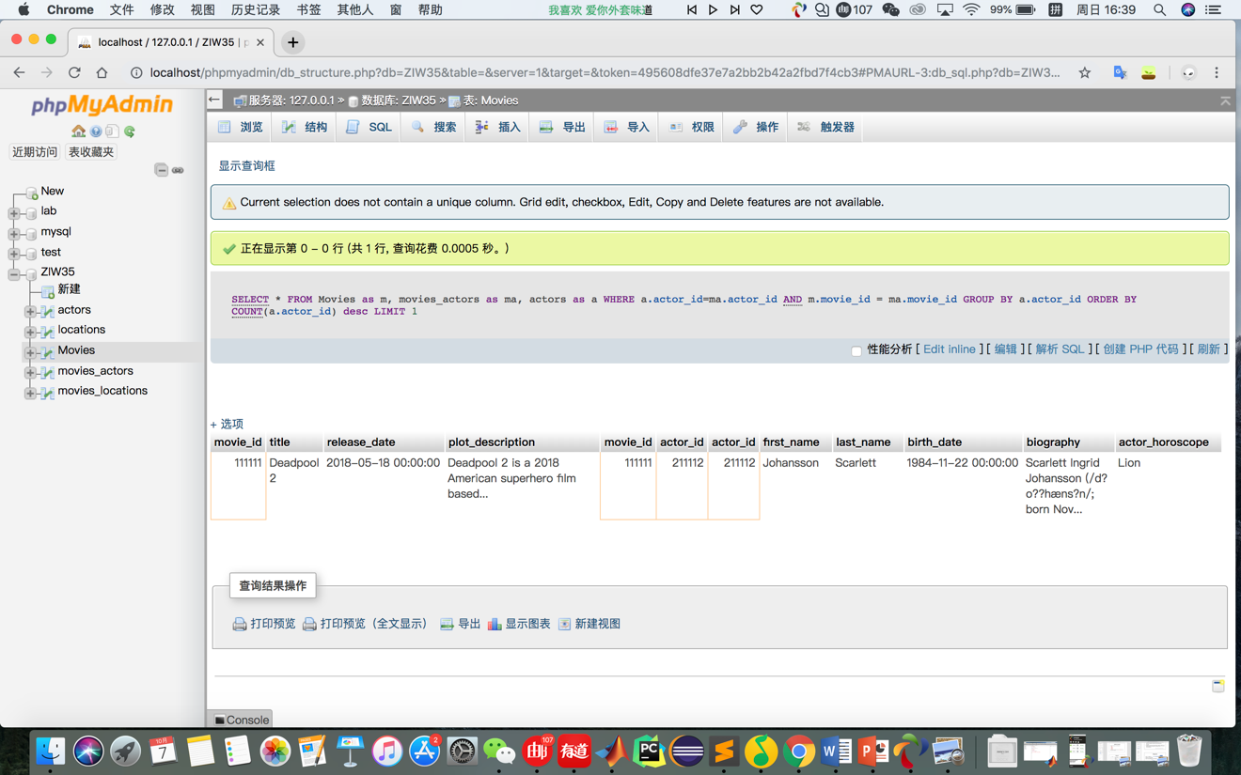

## Task 13

Because at first I set the city all the same, now I need to update the name of city.

[UPDATE](http://localhost/phpmyadmin/url.php?url=http://dev.mysql.com/doc/refman/5.5/en/update.html) locations [set](http://localhost/phpmyadmin/url.php?url=http://dev.mysql.com/doc/refman/5.5/en/set.html) city = 'shanghai' WHERE location\_id = 311112

[update](http://localhost/phpmyadmin/url.php?url=http://dev.mysql.com/doc/refman/5.5/en/update.html) locations [set](http://localhost/phpmyadmin/url.php?url=http://dev.mysql.com/doc/refman/5.5/en/set.html) city = 'chengdu' where location\_id = 311113

[update](http://localhost/phpmyadmin/url.php?url=http://dev.mysql.com/doc/refman/5.5/en/update.html) locations [set](http://localhost/phpmyadmin/url.php?url=http://dev.mysql.com/doc/refman/5.5/en/set.html) city = 'hohhot' where location\_id = 311114

[update](http://localhost/phpmyadmin/url.php?url=http://dev.mysql.com/doc/refman/5.5/en/update.html) locations [set](http://localhost/phpmyadmin/url.php?url=http://dev.mysql.com/doc/refman/5.5/en/set.html) city = 'beijing' where location\_id = 311115

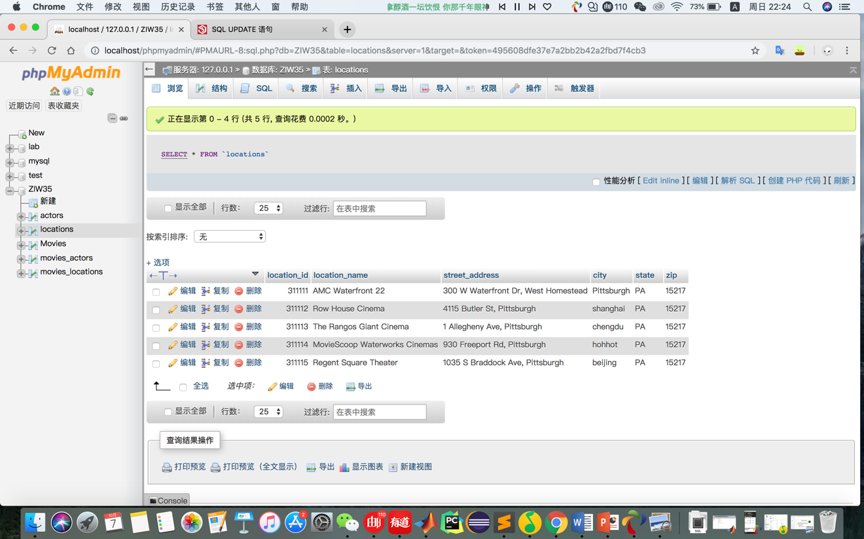

[SELECT](http://localhost/phpmyadmin/url.php?url=http://dev.mysql.com/doc/refman/5.5/en/select.html" \t "mysql_doc) city, [count](http://localhost/phpmyadmin/url.php?url=http://dev.mysql.com/doc/refman/5.5/en/group-by-functions.html#function_count)(actor\_id) from movies\_actors AS ma, locations AS l, movies\_locations as ml WHERE ma.movie\_id = ml.movie\_id [AND](http://localhost/phpmyadmin/url.php?url=http://dev.mysql.com/doc/refman/5.5/en/logical-operators.html#operator_and) l.location\_id =ml.location\_id GROUP by city

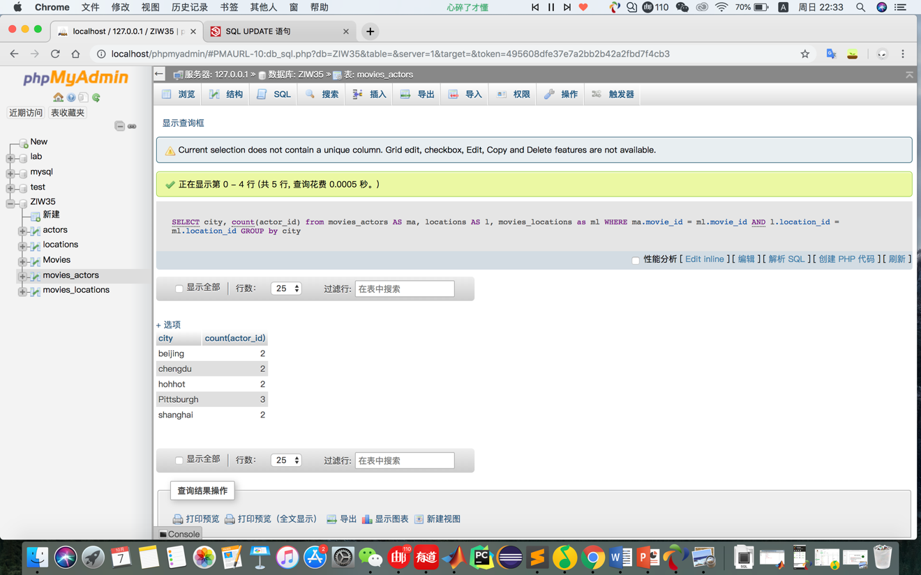

## Task 14